Use histogram of oriented gradients as feature vectors

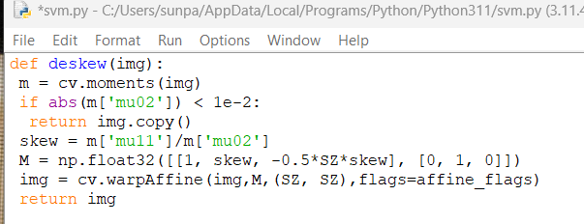

Attempt to deskew before hand using calculated moment and adjusting

Find sobel derivatives of each cell in the x and y direction, find their magnitude and direction of the gradient at each pixel

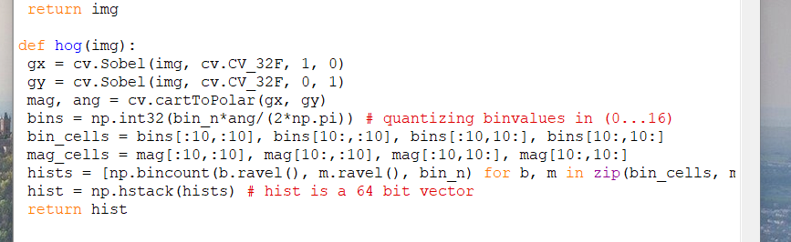

Return histogram with 16 bins

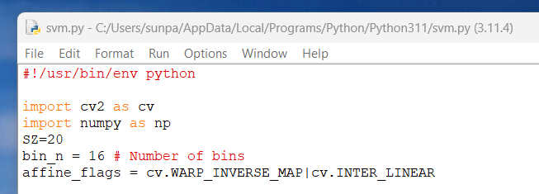

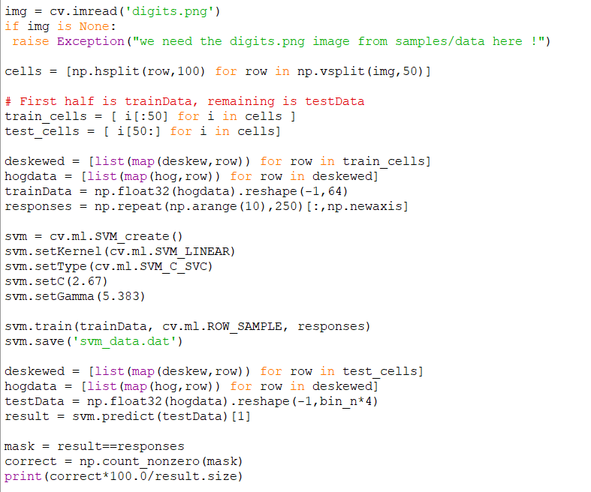

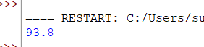

Had to change image to single channel grayscale, but I got 93.8% accuracy